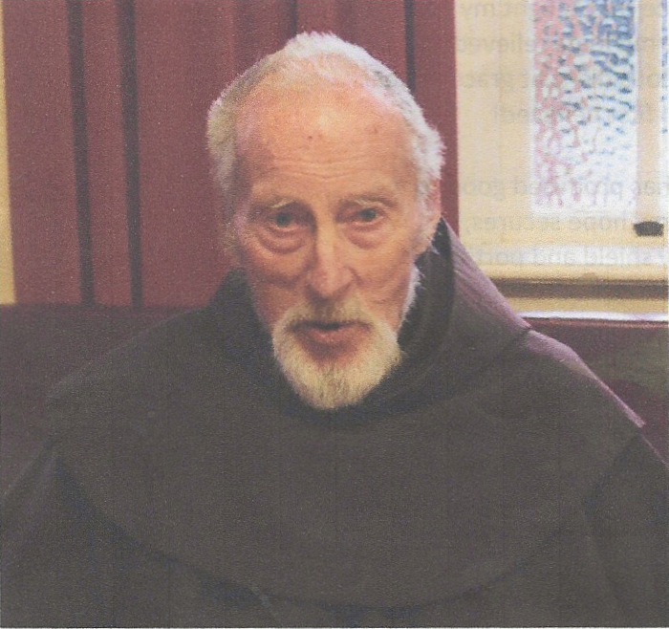

Peter Dalton
(known as Brother Christopher, 1958-1969)

Birth 17 October 1930
Novitiate 15 February 1958
Temp. Profession 17 August 1959
Solemn Profession 8 September 1962
Death 16 June 2019

1955-1957 Maryfields, Campbelltown Postulant, Building Team
1958-1959 Maryfields, Campbelltown Novice
1960 Maryfields, Campbelltown Building Team
1961-1962 St Anthony, Robertson Friary duties and maintenance
1963-1964 Maryfields, Campbelltown Building Team
1965 St Paschal, Box Hill Building Team
1966-1970 La Verna, Kew Retreat House staff
1971-1974 La Verna, Kew Retreat House staff; Asst Postulant Master
1975 Friary, Waverley Friary duties; Church sacristan
1976-1979 St Francis Retreat, Mt Roskill Regional director FMU, Mission Shop
1980-1983 Serra House, Remuera Regional director FMU, Mission Shop, Asst Postulant Master
1984-1986 St Francis Retreat, Mt Roskill Regional director FMU, Mission Shop
1987-1989 San Damiano, Mangere Bridge Regional director FMU, Mission Shop, Asst Postulant Master
1990-1995 San Damiano, Mangere Bridge Guardian, Regional director FMU, Mission Shop
1996-1998 St Francis Retreat, Mt Roskill Vicar, Regional director FMU, Mission Shop
1999 St Anthony Friary, Mangere Bridge Maintenance staff (Retreat House), Regional director FMU
2000 St Francis Retreat, Mt Roskill Maintenance staff, Regional director FMU, Asst Novitiate Director
2001-2015 St Francis Retreat, Mt Roskill Maintenance staff, Regional director FMU
2016-2019 St Francis Retreat, Mt Roskill Semi-retired

43 years 1976-2019 Resident in Aotearoa New Zealand
40 years 1976-2015 Regional director of Franciscan Missionary Union (FMU)
23 years 1976-1998 Franciscan Mission Shop, Onehunga
17 years 1999-2015 Retreat House (maintanance staff)

Year dates and descriptions taken from Tabula/Directory of Communities

